News Writing Techniques
Reporting
One of the most fundamental differences between journalism and other forms of writing is the way journalists obtain the information they write about. Journalists obtain information through a variety of reporting techniques, which can include interviewing sources, looking through government documents, researching old articles, and observing events firsthand.
Good news writing begins with good, accurate reporting. Journalists perform a public service for citizens by presenting truthful facts in honest, straight-forward articles.
News Values
Journalists commonly use six values to determine how newsworthy a story or elements of a story are. Knowing the news values can help a journalist make many decisions, including:
- What information to give first in a news article, and in the lead
- Which articles to display on a newspaper’s front page
- What questions to ask in an interview
The six news values are:
- Timeliness- Recent events have a higher news value than less recent ones.
- Proximity- Stories taking place in one’s hometown or community are more newsworthy than those taking place far away.
- Prominence- Famous people and those in the public eye have a higher news value than ordinary citizens.
- Uniqueness/oddity- A story with a bizarre twist or strange occurrences. “Man bites dog” instead of “dog bites man.”
- Impact- Stories that impact a large number of people may be more newsworthy than those impacting a smaller number of people.
- Conflict- “If it bleeds, it leads.” Stories with strife, whether it’s actual violence or not, are more interesting.
The newsworthiness of a story is determined by a balance of these six values. There is no set formula to decide how newsworthy a story is, but in general, the more of these six values a story meets, the more newsworthy it is.
Libel
Libel is defined as the published defamation of a person’s character based on misleading or inaccurate facts. Newspaper reporters can often run into issues of libel because it is their job to write truthful articles about people that might not always be flattering.
Even though we live in a country with a free press, journalists cannot write anything they want. Reporters do not have the right to state something about a person that could damage their reputation and that is untruthful.
One of the easiest ways to protect oneself from libel is to make sure to always do accurate reporting and to attribute all information in an article. If you write something about someone that you’re unsure about, just ask yourself if it’s true, and how you know it’s true. Rumors, gossip, and information you received from an anonymous or unreliable source are all dangerous to report, and they could run you the risk of a libel case.
Lede
The lede (or lead) of a news article is the first sentence, usually written as one paragraph, that tells the most important information of the story. When writing a lede, it is helpful to use the “tell a friend” strategy. Imagine you had to sum up to a friend, in one sentence, what your story is about. How would you sum up quickly what happened? A story’s lede answers the “Five W’s” in a specific order: Who? What? When? Where? Why?
For example:
The Atlanta Police Department will hold a memorial service Wednesday at Holy Christ Church in Buckhead for fallen officer Lt. James Montgomery.
WHO: The Atlanta Police Department
WHAT: will hold a memorial service
WHEN: Wednesday
WHERE: Holy Christ Church in Buckhead
WHY: for fallen officer Lt. James Montgomery
Other Examples:
Gwinnett County Public Schools was awarded $250,000 early Wednesday as a finalist for what’s considered the Nobel Prize of public education.
A man beat an Army reservist in front of a Morrow Cracker Barrel, yelling racial slurs at her as he kicked her in the head, Morrow police said.

Examples courtesy of the Atlanta Journal-Constitution
Inverted Pyramid
News articles are written in a structure known as the “inverted pyramid.” In the inverted pyramid format, the most newsworthy information goes at the beginning of the story and the least newsworthy information goes at the end.
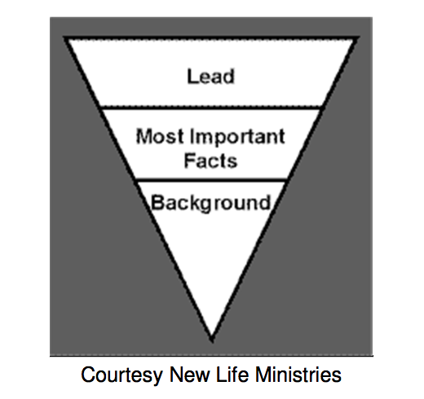
After you have written your story’s lede, order the information that follows in terms of most important to least important. There is NO formal conclusion in a journalism article the way there is in an essay or analysis paper.
Attributing information
ALL information in a news article MUST be attributed to the source where the reporter got his/her information. The reporter must indicate in his/her article where material was obtained from – from an interview, court documents, the Census, a Web site, etc. Direct quotes and paraphrasing can be used to attribute information obtained in an interview with a source.
For example:
According to a police report, the suspect threatened the cashier with a gun before running away with the money.
In a 500-page government report, investigators reported evidence that the army had committed crimes against humanity.
Integrating quotes
The first time a source is introduced in an article, you should use that source’s full name and title. After this initial reference, use the last name only.
For example:
“The swine flu vaccine is an incredible advance in modern medicine,” said Health and Human Services Secretary Kathleen Sebelius.
When attributing a direct quote, always use the verb “said” and never any other verbs such as “explained,” “whispered,” etc. It is also more common to use the format “XXX said” instead of “said XXX.”
For example:
“The housing crisis is growing out of control,” Bernanke said.
Even when information from a source is not used in a direct quote and is paraphrased instead, it still must be attributed to that source.
For example:
Bernanke said the recession is probably over.
The recession will most likely begin to recede in six to eight months, Bernanke said.

